**Developing MyJobs DB:**

Our idea is to design a MyJobs Database System using a Mongo Database in the background and a User Interface in the front with C#. The system will allow us to search for jobs in the traditional Job searching websites such as Higheredjobs.com. The interface will also allow us to narrow down the information with customized search key; save interested job posting information; categorize them into several groups such as Highly Relevant, Most Relevant, Less Relevant, Ready to Submit, Submitted, etc. It will also keep track of some other information such as: posting date, deadlines, areas of specialization, contact person. All data will be stored in a remote computer; and the database will be accessible and shared by authorized users.

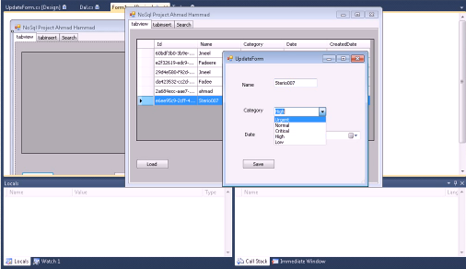

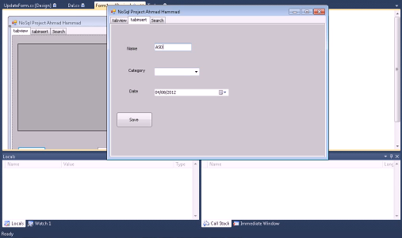

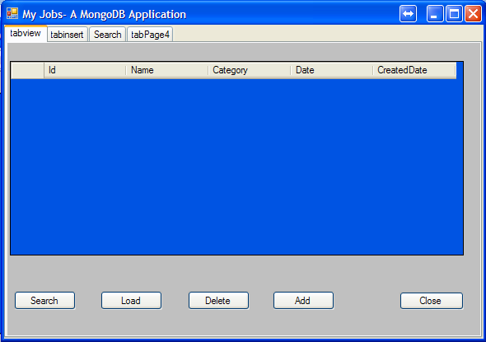

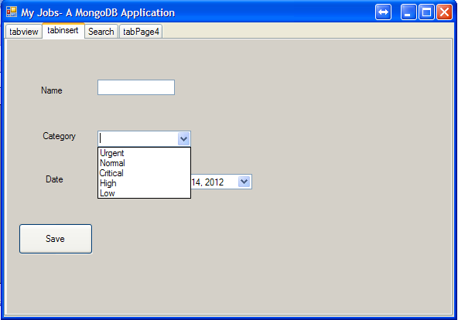

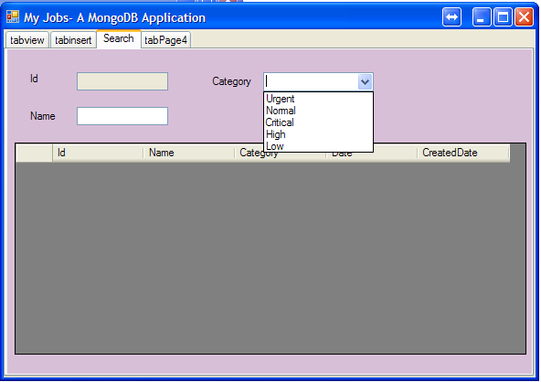

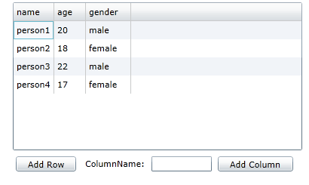

Codeling Article

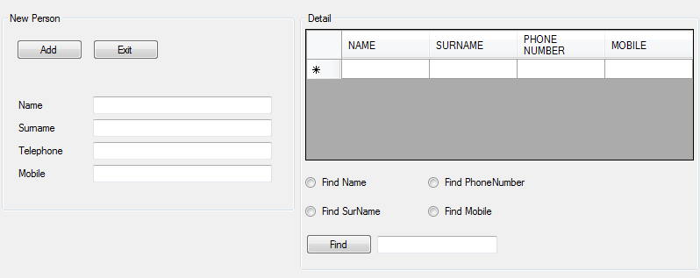

Example of Data Entry (Phone Book)

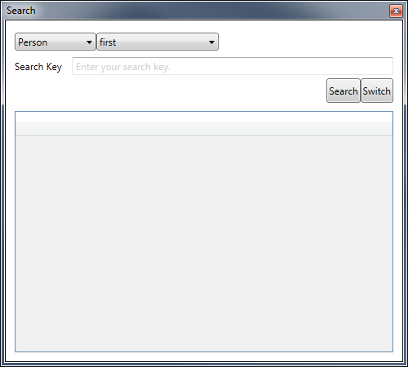 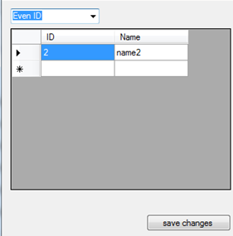

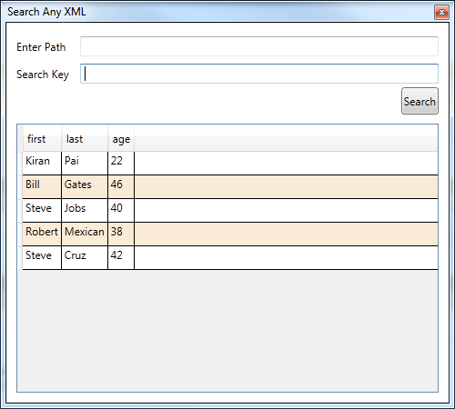

#### MongoDB Quick Start

http://www.mkyong.com/tutorials/java-mongodb-tutorials/

YouTube Videos:

# NoSQL Database Tutorial part2 | Installing MongoDB

<http://www.youtube.com/watch?v=-8WM1gduEH8&feature=channel&list=UL>

# MongoDB Installation

<http://www.youtube.com/watch?v=DYisYUgjsRg>

# How to configure MongoDb on Windows

<http://www.youtube.com/watch?v=GcV3XC3Rr8E>

**Introduction to MongoDb Database**

<http://www.youtube.com/watch?v=iRDOGkFKBRw>

<http://highoncoding.com>

# MongoDB Introduction and Installation

<http://www.youtube.com/watch?v=TcrSywaOsq8&feature=related>

# MongoDB Tutorial

# <http://www.mongodb.org/display/DOCS/Tutorial>

# Java MongoDB Tutorial

<http://www.mkyong.com/tutorials/java-mongodb-tutorials/>

<http://www.learn-with-video-tutorials.com/mongodb-video-tutorial>

**building-web-applications-mongodb-introduction**

<http://www.10gen.com/presentations/mongosf-2011/building-web-applications-mongodb-introduction>

# MongoDB Schema Design: How to Think Non-Relational

<http://www.youtube.com/watch?v=PIWVFUtBV1Q&feature=related>

# O'Reilly Webcast: Introduction to MongoDB

<http://www.youtube.com/watch?v=w5qr4sx5Vt0&feature=relmfu>

# Application Development

<http://docs.mongodb.org/manual/applications/#tutorials>

# Building Applications with MongoDB - An Introduction

<http://www.youtube.com/watch?v=UNYSTA4tMVY&feature=related>

<http://www.youtube.com/watch?v=UNYSTA4tMVY&feature=related>

# NoSQL Database Tutorial part1 | Introduction to NoSql

<http://www.youtube.com/watch?v=AMpvjJtcHsk&feature=relmfu>

# Introduction to MongoDB -- Part I

<http://www.youtube.com/watch?v=bwAqN9l14kI&feature=related>

# NoSQL Database Tutorial part2 | Installing MongoDB

# NoSQL Database Tutorial part3 |.Net C# DAL Application With

<http://www.youtube.com/watch?v=r7IufL6CzAo&feature=fvwrel>

# JavaScript Interface

<http://docs.mongodb.org/manual/reference/javascript/>